**Project 1.2**

**Project 1.2 - State-Wise Development Analysis in India**

Student Name: Abarajithan SA

Course: Big Data Hadoop & Spark Training

Contents

1.1 Project Overview 2

2. Product/Service Description 2

2.1 Assumptions 2

2.2 Constraints 2

3. Requirements 2

4. Dataset 3

4. Problem statement 3

Problem Statement1 - Find out the districts who achieved 100 percent objective in BPL cards Export the results to mysql using sqoop 4

Task 1 – Place Dataset in the target using flume, 4

Task2 – Create folders in the HDFS to store the outputs, 5

Task3 – Create Database and the Tables in the mysql 6

Task4 - PIG query to process XML and store into PIG table 7

Task5 – Find the districts who achieved 100 percent objective in BPL cards 8

Task6 – Verifying the stored results in the HDFS 10

Task7 – Export the results into mysql using sqoop 12

Task8 – verify the data exported to mysql 12

Problem statemet2 - Write a Pig UDF to filter the districts which have reached 80% of objectives of BPL cards. Export the results to MySQL using Sqoop. 15

Task1 – Create a PIG UDF using Java 15

Task2 - Write PIG query to find out the districts who achieved 80 percent objective in BPL cards 16

Task2 – verify the result stored in the HDFS 17

Task4 – Export the results into mysql table using sqoop command, 17

Task5 – Verify the result in the mysql 18

# Project Overview

To develop the System to analyze the log data (In XML format) of government progress of various development activities.

* 1. Purpose and Scope of this Specification

The following requirement will be addressed in phase 1 of Project:

* Developing system to handle the incoming log feed and store the information in HadoopCluster (Flume)
* Analyze the data and understand the progress
* Store the results in Hbase/RDBMS

Out of scope

We can use this data and visualization and get more insights

# 2. Product/Service Description

## 2.1 Assumptions

Log will be generated in XML format and stored in a server

## 2.2 Constraints

Describe any item that will constrain the design options, including

* This system may not be used for searching for now. But it will be used for analysis and saving the relevant information as of now
* System will be using Hbase as a database

# 3. Requirements

* The FLUME job which will format the data and place the data to HDFS
* Pig/MapReduce job for parsing the XML data.
* Create Pig scripts/MapReduce jobs to analyze the data
* Create the Sqoop job to store the data in database

Priority Definitions

The following definitions are intended as a guideline to prioritize requirements.

* **Priority 1** – Create FLUME job for fetching log files from spool directory the data
* **Priority 2** – MapReduce/pig job to preprocess

# 4. Dataset

Download the dataset using the below link:

Link: <https://drive.google.com/file/d/0Bxr27gVaXO5sUjd2RWFQS3hQQUE/view?usp=sharing>

Refer the below steps to understand the actual steps to create the above project.

**Step 1:**

Copy dataset from local file system to HDFS using flume.

Note: use the conf file by downloading from below link.



**Command:**

***flume-ng agent –n agent1 –c conf –f <path to filecopy.conf>***

**Step 2:**

Input file is in the XML format use Map reduce or pig to parse the data and get the results for the below problem statements.

# 4. Problem statement

1. Find out the districts who achieved 100 percent objective in BPL cards Export the results to mysql using sqoop
2. Write a Pig UDF to filter the districts which have reached 80% of objectives of BPL cards. Export the results to MySQL using Sqoop.

Project Execution

# Problem Statement1 - Find out the districts who achieved 100 percent objective in BPL cards Export the results to mysql using sqoop

## Task 1 – Place Dataset in the target using flume,

Place the flume config file provided at the location, **/home/acadgild/apache-flume-1.6.0-bin/conf**

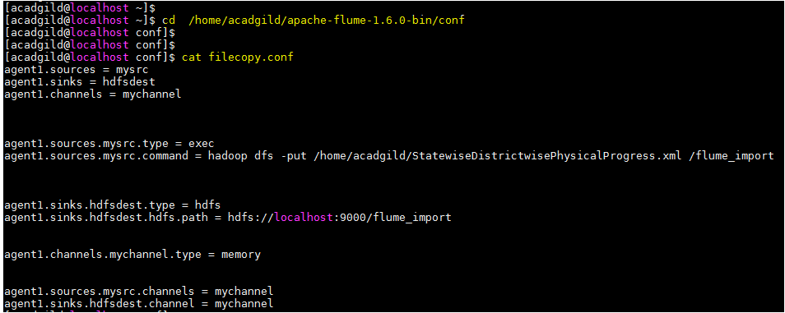

Copy the dataset downloaded from the link from local file system to HDFS using flume using the below command,

***flume-ng agent -n agent1 -c conf -f /home/acadgild/apache-flume-1.6.0-bin/conf/filecopy.conf***

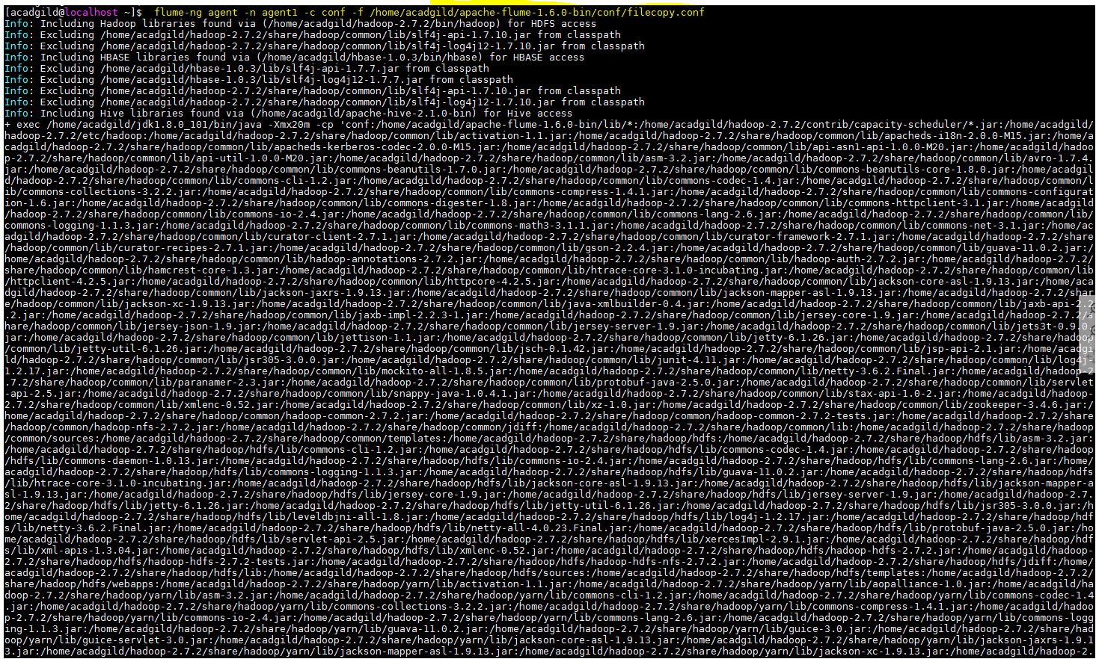

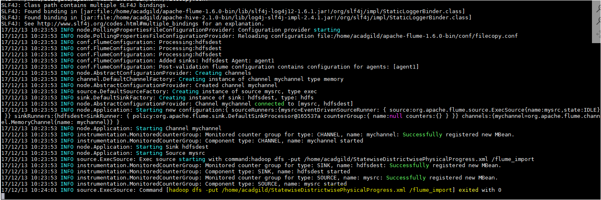

Verify whether the file is copied in the target,

***Hadoop fs –ls /flume_import***

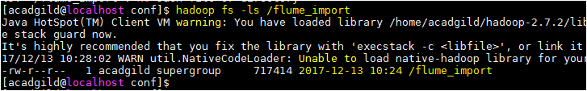

## Task2 – Create folders in the HDFS to store the outputs,

***hadoop fs -mkdir districts_100per_objectives***

***hadoop fs -mkdir districts_80per_objectives***

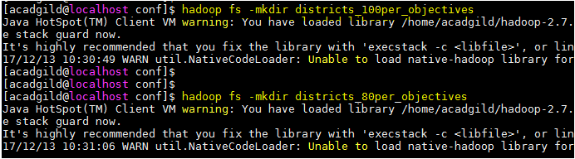

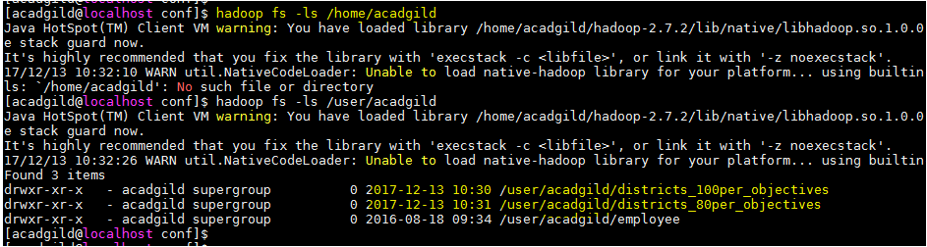

## Task3 – Create Database and the Tables in the mysql

Start mysql> sudo service mysqld start

Login as root user,

***create database project_bpl_cards;***

***use project_bpl_cards;***

***create table districts_100percent_objective (district_name varchar(50));***

***create table districts_80percent_objective (district_name varchar(50));***



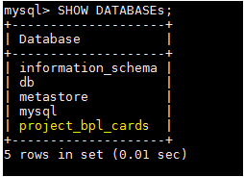



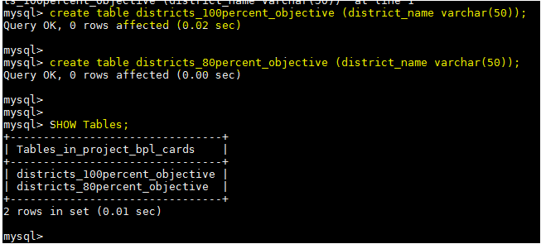

## Task4 - PIG query to process XML and store into PIG table

In this section we are going to Load data from HDFS to PIG alias ***StatewiseDistrictwisePhysicalProgress*** using below query:

***DEFINE XPath org.apache.pig.piggybank.evaluation.xml.XPath;***

***StatewiseDistrictwisePhysicalProgress = LOAD 'hdfs://localhost:9000/flume_import' USING org.apache.pig.piggybank.storage.XMLLoader('row') as (row:chararray);***

Next, iterate over each row and load into alias ***StatewiseDistrictwisePhysicalProgress*** which has schema fields same as XML schema hyphen (-) are replaced with underscore (_)

***PhysicalProgress = FOREACH StatewiseDistrictwisePhysicalProgress GENERATE XPath(row, 'row/State_Name') AS State_name,***

***XPath(row, 'row/District_Name') AS District_name,***

***XPath(row, 'row/Project_Objectives_IHHL_BPL') AS Project_Objectives_IHHL_BPL,***

***XPath(row, 'row/Project_Objectives_IHHL_APL') AS Project_Objectives_IHHL_APL,***

***XPath(row, 'row/Project_Objectives_IHHL_TOTAL') AS Project_Objectives_IHHL_TOTAL,***

***XPath(row, 'row/Project_Objectives_SCW') AS Project_Objectives_SCW,***

***XPath(row, 'row/Project_Objectives_Anganwadi_Toilets') AS Project_Objectives_Anganwadi_Toilets,***

***XPath(row, 'row/Project_Objectives_RSM') AS Project_Objectives_RSM,***

***XPath(row, 'row/Project_Objectives_PC') AS Project_Objectives_PC,***

***XPath(row, 'row/Project_Performance-IHHL_BPL') AS Project_Performance_IHHL_BPL,***

***XPath(row, 'row/Project_Performance-IHHL_APL') AS Project_Performance_IHHL_APL,***

***XPath(row, 'row/Project_Performance-IHHL_TOTAL') AS Project_Performance_IHHL_TOTAL,***

***XPath(row, 'row/Project_Performance-SCW') AS Project_Performance_SCW,***

***XPath(row, 'row/Project_Performance-School_Toilets') AS Project_Performance_School_Toilets,***

***XPath(row, 'row/Project_Performance-Anganwadi_Toilets') AS Project_Performance_Anganwadi_Toilets,***

***XPath(row, 'row/Project_Performance-RSM') AS Project_Performance_RSM,***

***XPath(row, 'row/Project_Performance-PC') AS Project_Performance_PC;***

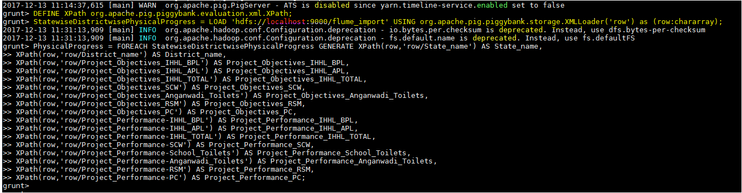

## Task5 – Find the districts who achieved 100 percent objective in BPL cards

Filter the records by ***Project_Objectives_IHHL_BPL*** is equal to ***Project_Performance_IHHL_BPL***

***PhysicalProgress_100_percentage_bpl = FILTER PhysicalProgress BY Project_Objectives_IHHL_BPL == Project_Performance_IHHL_BPL;***

Select only District_Name column,

***districts_100_percentage_bpl = FOREACH PhysicalProgress_100_percentage_bpl GENERATE District_name;***

Now store the data we received from the PIG alias ***districts_100_percentage_bpl*** into the HDFS locationwhere we created at the Task2

***STORE districts_100_percentage_bpl INTO 'hdfs://localhost:9000/districts_100per_objectives';***



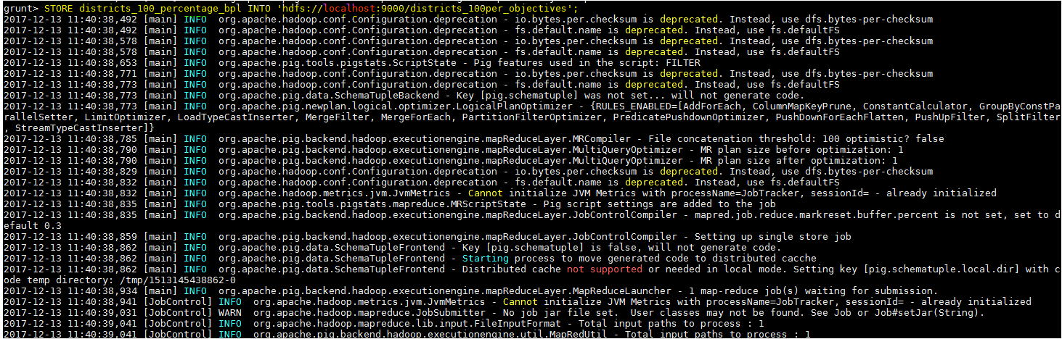

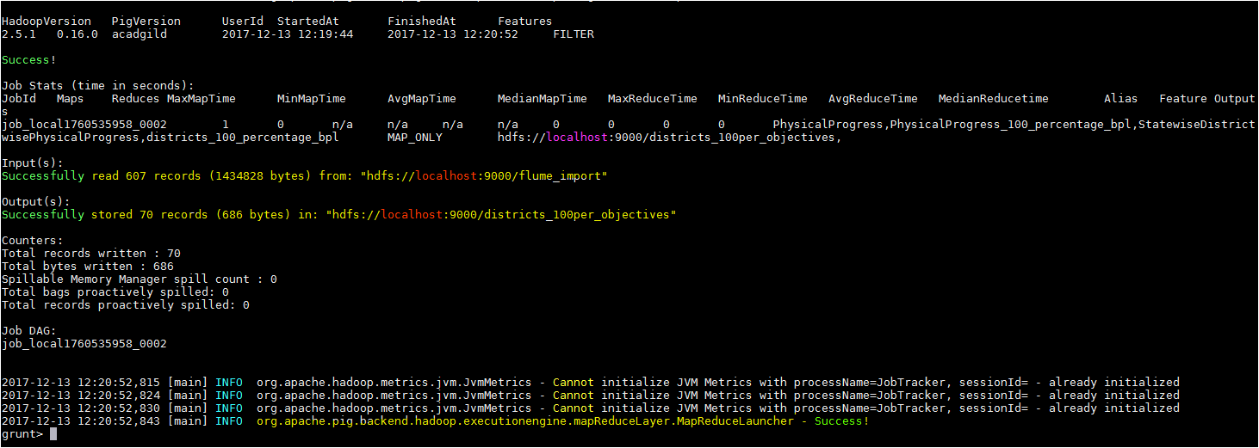

## Task6 – Verifying the stored results in the HDFS

***hadoop fs -ls /districts_100per_objectives***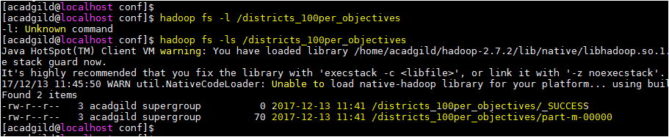

***hadoop fs -cat /districts_100per_objectives/\****

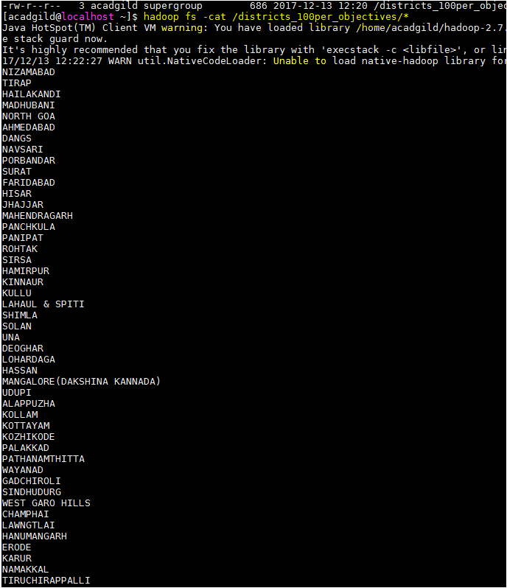

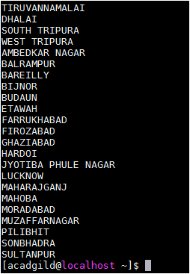

## Task7 – Export the results into mysql using sqoop

Sqoop command to export,

***sqoop export --connect jdbc:mysql://localhost/project_bpl_cards --username root --password acadgild --table districts_100percent_objective --export-dir '/districts_100per_objectives' --input-fields-terminated-by ',' -m1 --columns district_name***

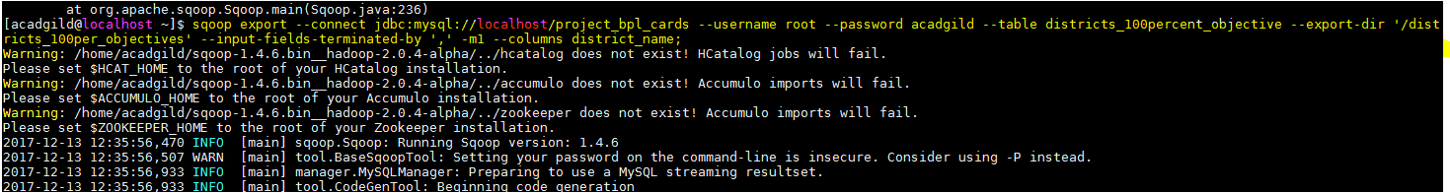 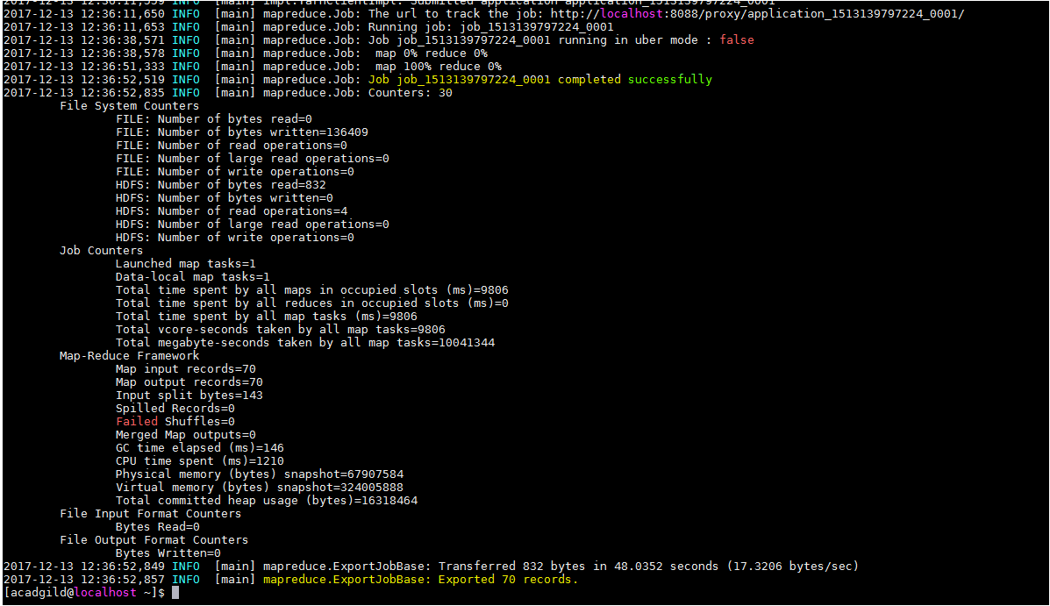

Task8 – verify the data exported to mysql

Use the following command in mysql to verify results in mysql

***select * from districts_100percent_objective;***

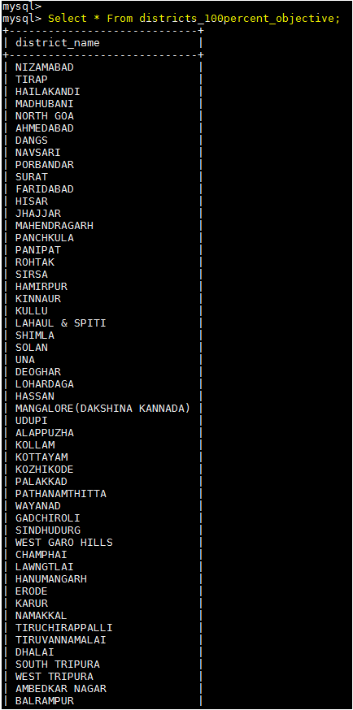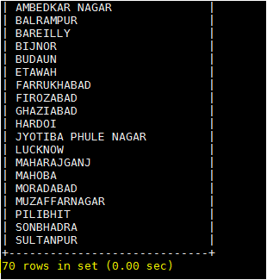

Hence as per the problem statement 1, we have successfully exported the result from HDFS to mysql database **project_bpl_cards** and into the table **districts_100percent_objective.**

# Problem statemet2 - Write a Pig UDF to filter the districts which have reached 80% of objectives of BPL cards. Export the results to MySQL using Sqoop.

## Task1 – Create a PIG UDF using Java

Create a Java project **Project_1_2** and Write a Java class **FilterDistrictsHavingEightyPercentBPL** in eclipse which will filter those tuples for which 80 percent objective in BPL cards are achieved. The logic put in exec method is value of **Project_Performance_IHHL_BPL** is equal to more than 80% of **Project_Objectives_IHHL_BPL.**

## Java code

**package** FilterDistrictsHavingEightyPercentBPL;

**import** java.io.IOException;

**import** org.apache.pig.FilterFunc;

**import** org.apache.pig.backend.executionengine.ExecException;

**import** org.apache.pig.data.Tuple;

**public** **class** FilterDistrictsHavingEightyPercentBPL **extends** FilterFunc

{

**public** Boolean exec(Tuple input) **throws** IOException

{

**try** {

Object value1 = input.get(0);

Object value2 = input.get(1);

**double** result =0.8 * (Integer.*parseInt*(value1.toString()));

**return** (Integer.*parseInt*(value2.toString()) >= result);

} **catch** (ExecException ee)

{

**throw** ee;

}

}

}

Export the Project2.jar to the acadgild local file system.

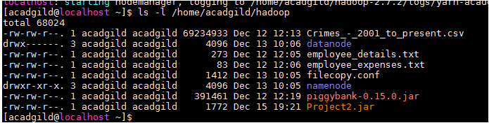

## Task2 - Write PIG query to find out the districts who achieved 80 percent objective in BPL cards

***Resgister /home/acadgild/hadoop/Project2.jar;***

Next, using the UDF filter those tuple for which **Project_Performance_IHHL_BPL** is equal to more than 80% of **Project_Objectives_IHHL_BPL,**

***physicalprogress_80_per_bpl = FILTER PhysicalProgress BY FilterDistrictsHavingEightyPercentBPL.FilterDistrictsHavingEightyPercentBPL(TOTUPLE(Project_Objectives_IHHL_BPL, Project_Performance_IHHL_BPL));***

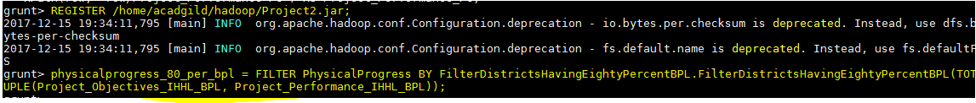

Next, select only **District_Name** field using command below:

***district_80_percent_bpl = FOREACH physical_progress_80_percent_bpl GENERATE District_Name;***

Next, Store into HDFS directory districts_having_100percent_objectives using command below:

***STORE district_80_percent_bpl INTO 'hdfs://localhost:9000/districts_having_80percent_objectives';***



## Task2 – verify the result stored in the HDFS

The following command shows that folders are created under districts_having_100percent_objectives,

***hadoop fs -ls / districts_80per_objectives***

***hadoop fs –ls / districts_80per_objectives/part-m-00000***

## Task4 – Export the results into mysql table using sqoop command,

***sqoop export --connect jdbc:mysql://localhost/bpl_results --username 'root' --table 'districts_having_80percent_objectives' --export-dir '/districts_having_80percent_objectives' --input-fields-terminated-by ',' -m 1 --columns name***

## Task5 – Verify the result in the mysql

***select * from districts_having_80percent_objectives***



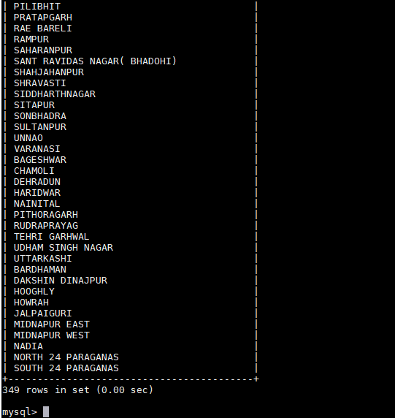

Hence, using PIG UDF we have got the result and stored into the mysql using sqoop commands.